SP Jain School of Global Management

FUNDAMENTAL STUDIES ON ARTIFICIAL NEURAL NETWORKS

Nam Pham

ID Stu: bs19bds025

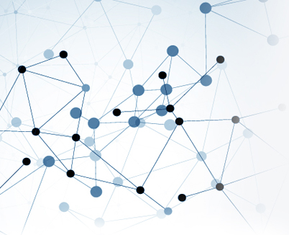

# **Everything needed to know about Artificial Intelligence, Machine Learning and Neural Networks:**

Over the past four years, the world has been witnessing huge strides in the quality and the "magic" of the technology products that we use every day.

Firstly, the voice recognition technology has been upgraded a lot compared to before. Thanks to it, users can now use voice commands to interact more with smart devices. Virtual voice assistants such as Amazon's Alexa, Apple's Siri, Microsoft's Cortana and voice recognition systems are present on almost every Google product that is blooming on multiple platforms, helping users actually show many different actions. On the other side of the globe, search giant Baidu is no less competitive with the statistics show that users of their products have used voice recognition three times in the past 18 months.

In addition to voice recognition, automatic translation and other natural language processing technologies are also getting better and better with big companies like Google, Microsoft, Facebook, Baidu, etc constantly launching unique features. Google Translate now has the ability to process spoken sentences from one language into 32 different language pairs, translate texts among 103 languages, and even translate real-time as soon as you pan the phone's camera through a foreign language billboard.

In fact, no engineer can program a computer to perform such features. Instead, they created an algorithm that allowed the computer to learn by itself and access to terabytes of related data - such as several hundred thousand pictures of dogs or voice tapes that last for long years. This constant exposure will gradually "train" the computer and make it recognize the images and voice required. Just like how a child learns about the world, after seeing for a long time the default images of a dog or hearing how people pronounce something, the computer will "see" where the dog is and "hear" what people are saying.

As such, AI (Artifical Intelligence), machine learning and neural networks are terms that describe how computers can do more complex tasks and learn from their environment. In fact, these three terms have very different meanings.

**Neural Networks analyzes complex data by simulating the human brain**

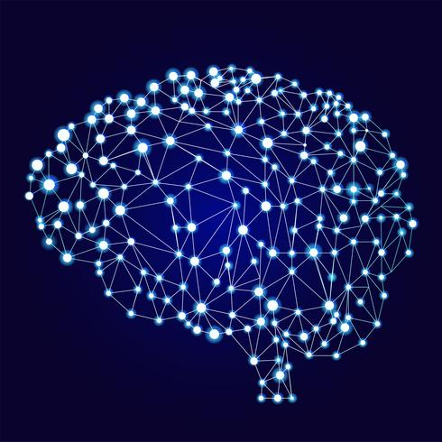The artificial neural network (ANN or Neural Networks for short) refers to a special learning model that mimics how synapses work in the human brain. Traditional computing uses a series of logical assertions to perform a task. Neural networks, on the other hand, use a network of nodes (acting as nerve cells) and edges (acting as synapses) to process data. The input data will run through the entire system and a series of output results are generated.

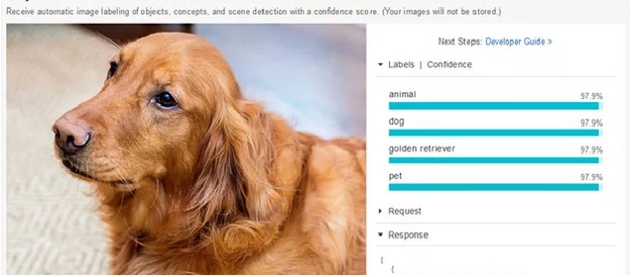The output will then be compared with the data the system has learned before. For example, if we want to train computer to recognize an image of a dog we will have to enter a system of millions of pictures of dogs so that the image looks like a dog. After that, we'll have to confirm which photos are actually a dog. Next, the system will prioritize this result across neural networks so it can find the correct result. Over time and millions of iterations, the network will eventually improve the accuracy of the results it produces.

Specifically, the structure of a basic neural network will include the following components:

• An input layer x

• An arbitrary number of hidden layers

• An output layer ŷ

• A set of weights and deviations between each class, W and b

• Activation function σ for each hidden floor

The following diagram shows the architecture of a 2-layer Neural Network (note that the input layer is usually excluded when counting the number of layers in Neural Network)

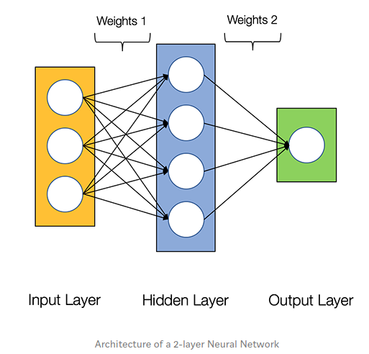

# Although this structure looks pretty simple but it is especially outstanding when we need to handle complex data. Google and Microsoft have been very accurate when using neural networks for translation applications because language translation is a very difficult job. Although there are still errors at present, with the ability to learn from accurate translations, neural networks can help the system deliver better results over time.

# The same thing happened with voice transcription technology. After Google applied neural networks to Google Voice, the phonetic transcription rate dropped to 49%. Although it is not possible to provide immediate and imperfect results, neural networks can analyze complex data very well and thus bring we more natural features in applications.

**Machine Learning teaches computers to improve skills**

Machine Learning is a broad term that includes anything in which we teach a computer to improve a task it is performing. More specifically, machine learning refers to any system where the performance of a computer when performing a task will get better after completing that task multiple times. Neural networks are an example of machine learning but that is not the only way computers can learn.

For example, one of the computer learning methods is Reinforcement Learning. In this method, the computer will perform a task and then its results will be graded. The way computers learn to play chess is an example. The computer will play a chess match and end it can win or lose. If it wins, its moves in that match will be labeled as winning. After playing millions of games, the system can identify which moves are most likely to help it win based on the results of previous matches.

While neural networks are great for things like pattern recognition in pictures, other types of machine learning are useful for other tasks, such as identifying wer favorite music. For example, Google says their music app will find we the music we want to hear. It does this by selecting playlists based on wer past listening habits. If we ignore the playlist it suggests, it will label the playlist as failing. However, if we select one of the suggestions, the system will successfully label the suggestion and reinforce the process of forming this suggestion so that it can provide more of such good suggestions in the future.

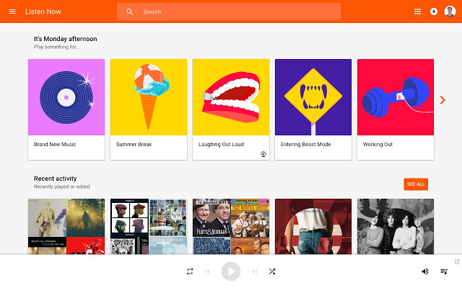

In this case, we will not be able to benefit from ML if we do not use this feature frequently. The first time we open the Google music app, all the suggestions we see have nothing to do with wer music taste. Theoretically, the more we use this app, the better the suggestions will be.

But machine learning is not perfect anyway, we will still get inappropriate suggestions. However, we will definitely get inappropriate suggestions if we only use this app every 6 months. If we do not use the application regularly to help the song suggestion system learn, it will not be much better than the conventional song suggestion system. As a buzzword, machine learning is more ambiguous than neural networks, but it still implies that the software we're using will use wer feedback to improve its performance.

**The term Artificial Intelligence used to refer to anything that is intelligent**

If neural networks are a form of machine learning, then machine learning is a form of AI. However, the list of what is considered AI is difficult to determine. We have now made significant achievements in AI technology. For instance, optical character recognition was once considered too complicated for computers, but now a phone app can scan documents and turn them into text. It seems a bit underestimating AI if we use this term to describe the current basic features.

However, since there are actually two different types of AI, the basic features will also be considered AI. Low-level or narrow AI is used to describe any system designed for one or a series of small tasks. For example, Google Assistant and Siri are designed to do a fairly small set of tasks, such as receiving voice commands and returning results or opening applications.

In contrast, high-level AI, also known as artificial intelligence in general or "Full AI", refers to a system capable of doing anything human can do. Naturally, this system does not or at least not yet exist. It's still a long way from building an AI system like Iron Man's assistant Jarvis.

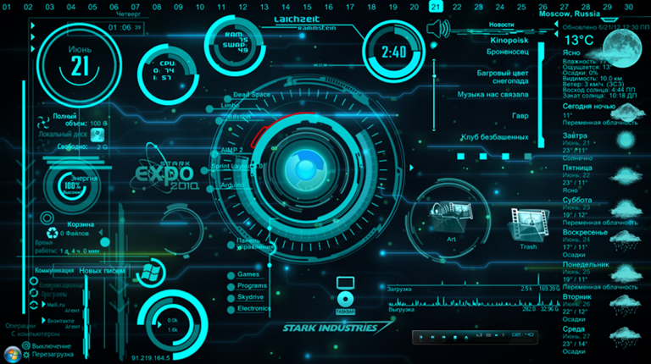

Because almost any AI we use right now is considered low-level, the term AI in the app description really just means it's a smart app. We may hear many announcements and advertisements but really the current AI is not comparable with human intelligence.

Practical research in the field of AI is very useful and perhaps we have applied it in daily life without knowing it. We can directly or indirectly benefit from AI research every time wer phone automatically remembers where we left off, recognizes faces in photos, suggests things we may be interested in. Or automatically group all photos into travel folder ....

At some point, AI will really help make apps smarter, as we expect. However, machine learning and neural networks are the only ways to improve certain features at the moment.

# **The explosion of the Deep Learning era:**

Back to the main topic of neural networks, what many people don't realize is that all of today's emerging technologies, essentially, come from the same source. They were developed from "**deep learning**", or as many scientists still prefer to call it the original name “**deep neural networks**”.

**Deep neural networks** are actually not a new concept but have been around since the 1950s. A lot of the breakthroughs in algorithms took place in the 1980s and 1990s. The main reason is that scientists are finally able to leverage all the computing power combined with the vast amount of data, images, video, audio and text files on the Internet - the deciding factors that help Neural networks can work effectively. Frank Chen, the coordinating partner of the renowned technology investment fund Andreesen Horowitz even compared these factors to the Cambrian boom in deep learning.

Advances in hardware have opened the door for a huge deep learning earthquake. The escalating computing power on devices not only comes from Moore's law but also from the arrival of NVIDIA's graphics processing unit (GPU) - the first generation of chips that is capable of delivering Great visual experience for users. Today, in addition to providing impressive 3D gaming experiences, GPUs are also widely used to speed computations in areas such as medical imaging, electronics, financial modeling, and scientific research. modern, image recognition, ... When operating deep learning algorithms, compared to just using traditional CPUs, GPUs help computers work smoothly up to 20-50%.

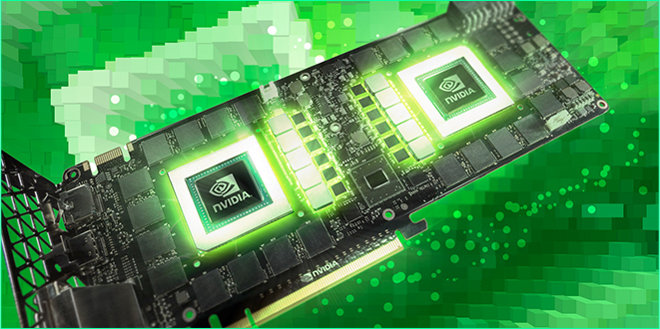

The second factor - the immense amount of data from the vast stock of photos, videos, audio, ... from the Internet and IoT devices - has ignited since the Internet was born but only really reached in the past 1-2 decades - when the number of netizens and smartphone coverage has increased rapidly.

These two catalysts have sparked a new revolution in deep learning. According to data from CB Insights, AI technology startups invested in the last quarter have reached a record high in history with a total of more than $ 1 billion. In the second quarter of 2016 alone, these startups held 121 rounds of fundraising, a jump compared to 21 rounds in the same period in 2011.

In 2012, Google only conducted two deep learning projects but now, this number has reached more than 1000 on most products such as Search, Android, Gmail, Translate, Wetube and self-driving cars. In 2011, IBM's Watson supercomputer only used AI to beat the best players in Jeopardy gameshow! But now it has also integrated deep learning into more than 30 service groups that this system provides. Investors who didn't even know what deep learning was 5 years ago started to be wary of investing in startups that didn't apply deep learning to their technology. Professor Andrew Ng., Director of Baidu's research center, said that "AI and deep learning are a new power that can revolutionize a wide range of industries in the same way that electrical networks have done. over 100 years ago."

Imagine what deep learning can do in the form of pairing inputs with outputs. We can give the system an audio file and get a subtitle file that records the content in it in the outputs. In another case, we can put in lots of emails and then ask the outputs to sort out what is spam email. Alternatively, we can also apply for a loan application and ask for an analysis of the object's ability to repay the outputs. All we need to do is put in the neural network a large amount of data and "take" what we need at the outputs. In this way, as long as we have enough data to load into the system, the potential for application and revolutionizing the industries of **deep learning** or **neural networks** is limitless.

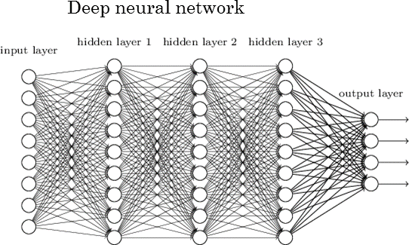

**SO HOW CAN DEEP LEARNING OR NEURAL NETWORKS BE APPLIED IN REAL LIFE?**

If we find features such as voice recognition when using Google voice search or image recognition of friends to suggest tagging them on Facebook are nothing too groundbreaking, remember that this is the dawn of the age of deep learning and AI only. Neural networks has a lot of great potential, but within the scope of this research, we can only go through some outstanding examples below.

**Eyes for the blind**

Deep learning in the future will certainly not stop at identifying images on ordinary machines. Computers will soon be able to identify each thing present in the scene and describe it.

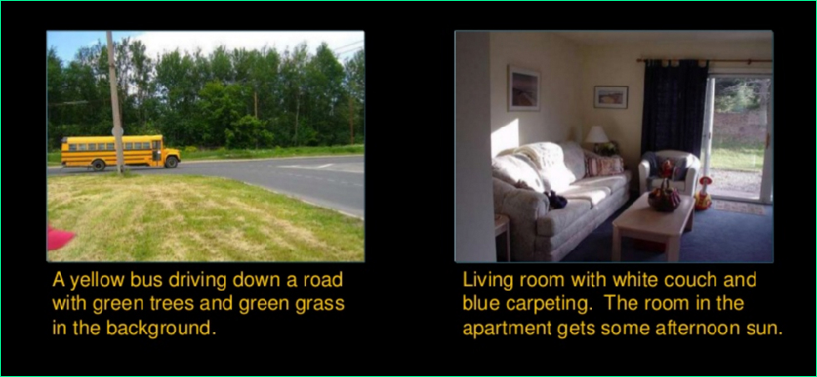

Once a computer can identify everything with the same level of detail as a human, there's no reason it can't hear / see for deaf / blind users. In fact, Baidu has developed Baidu Light, a wearable device that can take pictures of everything around them and present a caption describing them to users.

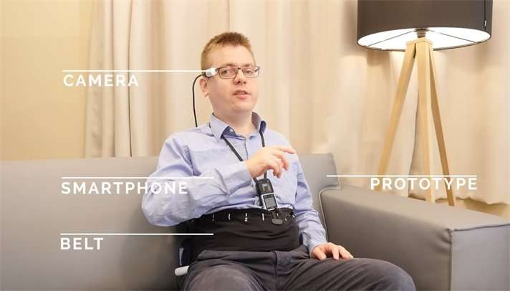

**Change the way robots and IoT products are designed**

Researchers have now been able to improve speech recognition accuracy from 89% to 99%. This meager 10% will essentially change everything.

Not to mention the large number of illiterate people in the world who have early access to smart devices like smartphones, this recognition capability is clearly paving the way for voice-based protocol platforms among people with computers, allowing us to talk and dictate our smartphones, cars, smart home appliances, or even the homes we live in without the bulky screens.

Furthermore, future helper robots can completely "understand" humans and "see" everything around them to perform tasks at a high level of accuracy.

**Suggestion systems on platforms**

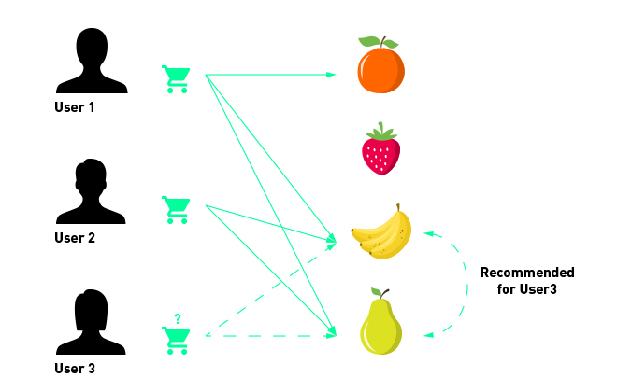

Major platforms such as Facebook, Amazon, Netflix, Wetube and Coursera all have a strong suggestion system, which significantly increases user interaction. Specifically, they are based on user generated data to suggest more products they will like (on shopping platforms), movies they will want to watch (on Netflix, Wetube), appropriate / sponsored posts (on Facebook) or interested learners courses (on online learning platforms such as Coursera, edX, etc).

**Big impact on financial industry**

Finance is one of the key areas that will witness the impact of AI and deep learning. Financial companies have been using algorithms to predict trends in the stock market, converting data more securely to promptly preventing fraudulent transactions. In the future, many banks and financial groups will be able to synchronize chatbots into their services to provide customers with the necessary advice in anywhere, at anytime. By superior natural language processing, financial advisory chatbots will analyze to determine their consumption and investment habits to give the most appropriate and personalized guidance possible.

**Health industry revolution**

Deep learning can make a lot of breakthroughs in many different health segments.

Enlitic is a medical startup using deep learning to analyze and identify pathologies from CT and MRI scans. In a number of previous trials, though not yet officially licensed, Enlitic's deep learning algorithms outperformed all four radiologists who were able to identify benign tumors. and malignant through film images.

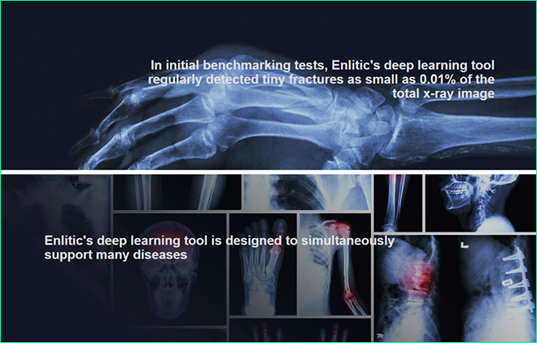

Meanwhile, Merck and Atomwise startups are applying deep learning to accelerate research speed of current medicines. Instead of testing each substance as before, scientists can use artificial neural networks to examine 3D images of thousands of molecules of substances that have the potential to be included in drug preparation and predictions. suitability in controlling their pathogens. Another potential of deep learning in this area is the development of surgical robots with high accuracy and the ability to receive real-time voice commands from the operator.

However, while these applications are focused on upgrading what people are doing, the fledgling startup Freenome is studying things that people have not done: identifying cancer through blood samples of patients. With the power of deep learning, Freenome can ask the computer to find similarities between free DNA in blood vessels (cell-free DNA) and cancer cells. The company said it had witnessed the first positive signs that cancer researchers have not yet seen.

Explaining this, Vijay Pande, Andreesen Horowitz's head of biotechnology investment, said if an X-ray doctor could see thousands of films taken during his career, a machine viewable millions of such sheets in a short time. They excel because they are exposed to so much data that humans cannot "digest" it. The final result is that in addition to increased quality and reduced costs, future health services will become much more transparent and accessible.

**THE DARK SIDE OF NEURAL NETWORKS**

Faced with massive breakthroughs in the field of deep learning in particular and AI in general, the ever-controversial issue remains whether computers and robots will ever rise and control humanity?

Leading the optimistic view on the future of AI is a series of leading figures from large organizations such as IBM, Google, Stanford University, Baidu, etc. According to Guru Banavar, IBM's research director, in the long run, AI will mainly work with humans to solve painful problems such as diseases and poverty through breakthroughs in biomedical engineering, education and applications in agriculture, finance, business, etc. We also do not need to worry too much about the ability of AI because of how smart it could become, the computers will never have the same perception as humans.

Geoffrey Hinton, one of the pioneering scientists in the field, said: "Even the largest neuron networks today are still hundreds of times smaller than the human brain. 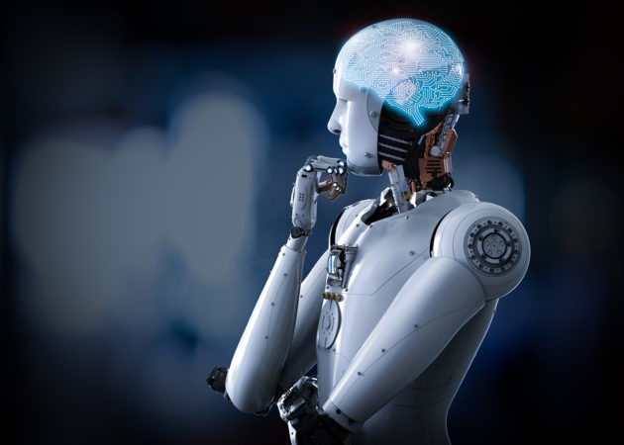Basically, AI are better than humans in the capability of capturing and mining large amounts of data, as well as recognizing specific trends and patterns in a short period of time, without having independent thinking like children people. This means they cannot ask themselves questions about what they do or understand why they do such things. Professor Andrew Ng. Baidu's same opinion holds that, "There is a huge difference between intelligence and sensory perception. Software can become smarter but in the end, they still have no perception."

Meanwhile, those who do not directly research in the industry bring more insecure view of this technology. Elon Musk and physicist Stephen Hawking had both shared concerns that humans could create horrible, uncontrollable AI machines. American author James Barrat also pointed out in his famous book Our Final Invention that AI, like nuclear fission technology, can become a double-edged sword when used in the wrong direction. At a high level, AI can be even more dangerous than the nucleus because they have been and are being introduced into military weapons such as self-driving drones and battle robots. At the border of South Korea, people are currently using SGR-1, a sentry robot with thermal and motion sensors that can identify a suspect target from a distance of more than 2 miles. Currently, the SGR-1 still has to wait for a signal from a human to start firing, but the problem is what will happen if such robots can automatically fire without human intervention?

According to Noel Sharley, the activist leading the Stop Killer Robots campaign, military leaders will send more and more robots to the front lines to minimize the loss of soldiers and this is the real threat. Most countries, including Russia, China and South Korea, are developing this kind of technology that is capable of disrupting global security.

In any case, at the present time, we can only base on what we know to judge this concern. Skeptics are not unfounded and AI optimists are not completely ignorant of those dark perspective alternatives. Typical of these are projects such as OpenAI, a non-profit startup founded by Elon Musk and Sam Altman, chairman of the Y Combinator startup incubator, whose mission is to research and provide AI source code for everyone. approach to "AI does not fall into the hands of a minority monopoly group". Recently, the AI ​​development alliance led by Google, Facebook, Microsoft, IBM and Amazon has also been formally established with the goal of jointly supporting the research of ethical, transparency and personal security during the application of this technology. We also have the right to hope for AI agreements that the countries of the world can join hands to establish in the near future.

 Fear of AI is nothing unreasonable, but if viewed fairly, almost no technology is without its two sides. How a technology becomes, after all, largely depends on how people control it and use it. And AI or deep learning is certainly no exception.

* THE END -